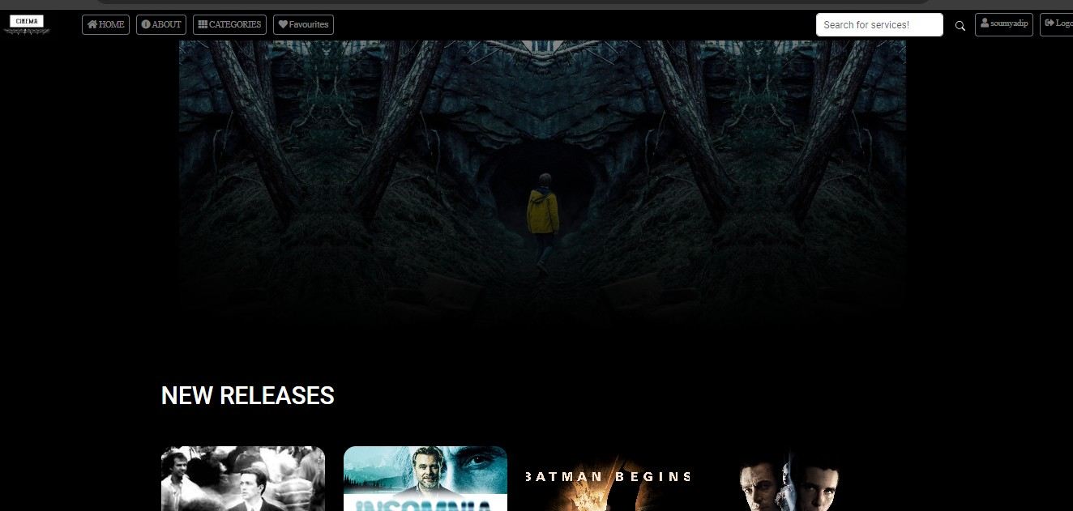



AN OTT PLATFORM

**(Online Movie Streaming Website)**

**Using Java Full Stack Development (Springboot)**

Project Report submitted in partial fulfillment of The requirements for the degree of

Bachelor of Technology Of

Maulana Abul Kalam Azad University of Technology by ISHANI BHOWMICK ( University Roll- 34230921007 )

Future Institute Of Technology Garia, Kolkata-700154

**An Ott Platform**

**(Online Movie Streaming Website)**

Under Guidance

Of

Mr. Anindya Mukherjee

Subject Matter Expert(JEE using Spring Boot)

Ardent Computech Pvt Ltd(AnISO9001:2008Certified)

Module-132, SDF Building, Sector-V,Salt Lake City,Kolkata-700091

A

Project Report

Submitted In Partial Fulfillment Of The Requirements

For The Award Of the

Bachelor of Technology

Project Carried Out At



Ardent Computech Pvt Ltd (An ISO9001:2008 Certified)

CF-137, Sector-1, Salt Lake City, Kolkata - 700064

Submitted By

Ishani Bhowmick

Department Of Computer Science And Engineering (Internet of Things and Cyber Security including Block Chain Technology)

Future Institute Of Technology

GARIA-700154

West Bengal |INDIA |

**An Ott Platform**

**(Online Movie Streaming Website)**

**Project Submitted by:**

**ISHANI BHOWMICK ( University Roll- 34230921007 )**

**Under the guidance of:**

**Prof. Anindya Mukherjee**

**Department of CSE(IOT CS – BCT)**

**240 Boral Main Road, Garia, Kolkata-700154**

This Project Thesis is submitted in partial fulfillment of the requirement for the Bachelor of Technology under Maulana Abul Kalam Azad University of Technology.

**Project Submitted By: Ishani Bhowmick**

**Signature------------------------------------**

**Under the guidance of: Anindya Mukherjee**

**Signature of the Project guide--------------------------------------**

Department of CSE(IOT CS – BCT).

Future Institute Of Technology

Garia, Kolkata-700154

.



This is to certify that this project report titled **An Ott Platform (Online Movie Streaming Website) Using Java Full Stack Development (Springboot)** Submitted in partial fulfillment of requirements for award of the degree Bachelor of Technology of Maulana Abul Kalam Azad University of Technology is a faithful record of the original work carried out by -

**ISHANI BHOWMICK**

**( REGISTRATION NO – 213420130910005 OF 2021-22 )**

**&**

**(UNIVERSITY ROLL NUMBER - 34230921007 )**

Under my guidance and supervision. It is further certified that it contains no material, which to a substantial extent has been submitted for the award of any degree/diploma in any institute or has been published in any form, except the assistances drawn from other sources, for which due acknowledgement has been made.

(*Signature of HOD) (Signature of project guide)*

*……………………………… …………………………………*

**Dr. Tanusree Chatterjee Anindya Mukherjee**

Future Institute Of Technology

Garia, Kolkata-700154

**DECLARATION**

We hereby declare that this project report titled

**An Ott Platform (Online Movie Streaming Website) Using Java Full Stack Development (Springboot)** Is our own original work carried out as a under graduate student in Future Institute of Technology College except to the extent that assistances from other sources are duly acknowledged.

All sources used for this project report have been fully and properly cited. It contains no material which to a substantial extent has been submitted for the award of any degree/diploma in any institute or has been published in any form, except where due acknowledgement is made.

|  |  |  |
| --- | --- | --- |
| Students Name | Signature | Dates |
| …………………………………. | ………………………………….. | …………………… |
| …………………………………. | ………………………………….. | …………………… |

**CERTIFICATE OF APPROVAL**

We hereby approve this dissertation titled **An Ott Platform (Online Movie Streaming Website) Using Full Stack Development With Java (Springboot)**

Carried out by

**Ishani Bhowmick ( Registration No – 213420130910005 Of 2021-22, University Roll Number - 34230921007 )**

Under the guidance of

**Anindya Mukherjee**

Of Future Institute of Technology College, Kolkata in partial fulfillment of requirements for award of the Bachelor of Technology of Maulana Abul Kalam Azad University of Technology West Bengal.

Date: ..........................

Examine’s Signatures:

1. …………………………………………

2. …………………………………………

**ACKNOWLEDGEMENTS**

The achievement that is associated with the successful Completion of any task would be incomplete without mentioning the name of **Ishani Bhowmick** whose endless cooperation made it possible. We take this opportunity to express our deep gratitude towards our project mentor **Mr.** **Anindya Mukherjee** for giving such valuable suggestions guidance and encouragement during the development of this project work. Last but not the least we are grateful to all the faculty members of **ARDENT COMPUTECH PRIVATE LIMITED** for their support.

Dated: ……………….. **Ishani Bhowmick**

**Index**

Introduction 1

Abstract 2

Hardware And Software Requirements 3

Requirements Specification 4

System Model 5

Functional Requirements 5

The Ott Platform 5

Ott Management System 6

User Interface Specifications 6

The Ott Platform 6

Ott Management System 7

Non-functional Requirements 7

System Evolution 8

System Design 8

Testing Design 11

Testing Phases 12

Database 12

ER Diagram For The Ott Platform 12

Sequence Diagram For The Ott Platform 14

DFD For the Ott Platform 15

Use Case Diagram For the Ott Platform 16

Introduction

An OTT platform, which stands for "Over-the-Top", refers to a service that delivers streaming media content directly to users over the internet. This bypasses the traditional methods of cable, satellite, or broadcast television providers. In recent years, the popularity of OTT platforms has surged, driven by advancements in technology, increased internet penetration, and changing consumer preferences.

It’s a mode of providing content over the top of an internet stream, without a third-party operator controlling or managing the content. The process allows OTT service providers to distribute content through a free transmission system (the public internet). Notably, content is delivered “upon request”, when a user clicks on a video through an app or on a device.

Users can access content at their convenience, streaming movies instantly, without waiting for scheduled broadcasts.

OTT platforms provide users with a vast library of movies, accessible anytime, anywhere, and on any internet-connected device. From on-demand streaming to live broadcasts, these platforms cater to a wide array of tastes and preferences, offering personalized viewing experiences tailored to individual users.

Leveraging the power of Spring and Spring Boot, we have crafted a robust and scalable solution that meets the demands of modern media consumption.

Abstract

In the realm of digital entertainment, Over-The-Top (OTT) platforms have emerged as a dominant force, revolutionizing how audiences consume video content. In this abstract, we present the development of an OTT platform leveraging the power of Spring and Spring Boot frameworks. The platform caters to the ever-growing demand for on-demand video and audio streaming, offering users a flexible and personalized entertainment experience. Spring provides a robust and modular framework, while Spring Boot streamlines application configuration, enabling rapid development. We utilize the Spring Framework to implement core functionalities of our OTT platform, including dependency injection, aspect-oriented programming, and transaction management. Spring's modular and flexible architecture enables us to build and maintain complex applications with ease. Our OTT platform adopts a microservices architecture, dividing functionalities into independent, loosely coupled services. Each microservice, built using Spring and Spring Boot, focuses on a specific aspect of the platform, such as user authentication, content management, or recommendation systems. This approach enhances scalability, resilience, and maintainability while facilitating continuous deployment and integration. Security is paramount in our OTT platform, and we leverage Spring Security to implement robust authentication, authorization, and data protection mechanisms.

Hardware And Software Requirements

Hardware

Dell Inspiron 15 3000 Series Laptop

Processor –Intel I3

Ram- 4gm

Harddisk-1000 Gb

Operating System Used

Windows 7 64 Bit

Tools Used

Spring Tool Kit

Mysql

Framework Used

Spring And Springboot

Language Used

Java

Html

Css

Javascript

Mysql

Database Used

Tomcat

Jdk Used

Jdk Version 17

Requirements Specification

System Model

The OTT Platform is designed to deliver high-quality video content to users over the internet, offering a seamless streaming experience across various devices. At its core, the platform consists of multiple interconnected modules, each responsible for specific functions, including content management, user authentication, recommendation systems, and analytics. The system adopts a microservices architecture, dividing functionalities into independent, modular services that communicate via well-defined APIs. The key components include user management service content management service recommendation engine streaming service analytics and monitoring.

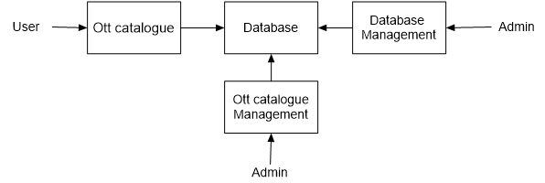

Functional Requirements

The video streaming platform is designed to offer a user-friendly and engaging experience. A robust user authentication system allows viewers to register, log in securely, and access personalized content based on their subscriptions and viewing habits. Intuitive search and browse functions empower users to discover new favourites by genre, category, trending content, or personalized recommendations. To ensure a seamless viewing experience, the platform offers smooth, uninterrupted playback across various devices, with features like adaptive streaming for fluctuating bandwidth and the ability to download content for offline viewing. On the backend, a comprehensive content management system allows authorized users to upload, organize, and enrich video content with detailed descriptions, thumbnails, and promotional materials. To cater to different viewing preferences, the platform offers a variety of secure payment options and flexible subscription plans. Users can easily manage their accounts, upgrade or downgrade plans, and ensure continued access to their desired content. Additionally, optional social features like sharing recommendations, rating content, and engaging in discussions can foster a sense of community and further enrich the user experience.

The Ott Platform

Users of the Ott platform, namely restaurant customers, must be provided the following functionality:

* Create an account.
* Manage their account.
* Log in to the system.
* Navigate the Ott catalogue.
* Select any show from the catalogue.
* Customize audio/caption language for a selected show.
* Add an item to their favourites list.
* Review their favourites list.
* Remove an item/remove all items from their favourites list.

As the goal of the system is to make the process of watching movies as simple as possible for the users, the functionality provided through the Ott platform is restricted to that which most pertinent to accomplish the desired task. All the functions outlined above, with the exceptions of account creation and management, will be used every time a customer places an order. By not including extraneous functions, it only facilitates the goal of simplifying the binging experience.

Ott Management System

The Ott management system will be available only to the admin and will, as the name suggests, allow them to manage the movie catalogue that is displayed to users of the Ott system. The functions afforded by the Ott management system provide user with the ability to, using a graphical interface:

* Add a new show to the Ott catalogue.
* Diagram a new show to the Ott catalogue.
* Delete an existing show from the Ott catalogue.

It is anticipated that the functionality provided by this component will be one of the first things noted by the Ott user, as they will have to go through it to configure their Ott platform before beginning to binge the shows. Once everything is initially configured, however, this component will likely be the least used, as movie catalogue updates generally do not occur with great frequency.

*User Interface Specifications*

Each of the system components will have their own unique interface. These are described below.

The Ott Platform

The Ott platform caters to restaurant customers seeking a hassle-free entertainment experience. Upon arrival, logging in is a breeze with username, password, and optional credential saving. Navigation is intuitive, offering dedicated sections for Home (featuring curated content and recently watched shows), Browse (categorized by genre, release year, or popularity for easy discovery), Search (to pinpoint specific titles), and Favourites (a personalized space to manage liked shows). Content discovery is further enhanced by clear and concise information on each content card, including titles, thumbnails, brief descriptions, and a prominently placed play button for immediate viewing. Once a show is selected, playback controls ensure a smooth experience with play/pause, rewind/fast-forward buttons, a progress bar for navigating within the content, a full screen toggle, and clearly labelled options for selecting audio and caption

language. Adding shows to the Favourites list is a simple tap on a star icon, and a dedicated Favourites section allows for easy management, including removing individual shows or clearing the entire list.

The user interface prioritizes a design philosophy that emphasizes simplicity for clear and uncluttered navigation. Text is easily readable with proper font size and color contrast, ensuring accessibility for all users. The layout is responsive, adapting seamlessly across various screen sizes, whether customers are using their phones or tablets. While account management isn't a core function used every time, the platform allows access through a profile menu for updating information, changing passwords, or managing payment methods if applicable. By focusing solely on features essential for browsing, selecting, and enjoying content, and prioritizing performance with fast loading times and smooth playback, the Ott platform creates a user-friendly environment that seamlessly integrates into the restaurant experience.

Ott Management System

The Ott Management System functions as a secure web-based hub exclusively accessible to authorized administrators. This behind-the-scenes interface prioritizes clear organization and a user-friendly design, empowering admins to curate the movie catalogue available to Ott users. Streamlining content population, the system offers a dedicated section for effortlessly adding new shows. Here, admins can upload essential details like titles, synopses, genre classifications, release years, and even thumbnail images. Maintaining the catalogue's accuracy is equally important. The editing function utilizes a similar interface, allowing admins to update existing show details, rectify missing information, or adjust genre placements. To ensure unwanted content doesn't clutter the user experience, admins also have the authority to delete shows from the catalogue entirely. A crucial confirmation step safeguards against accidental deletions. While the Ott Management System might see intensive use during the initial platform configuration to populate the library, its intuitive design ensures efficient content management throughout the platform's lifecycle, allowing admins to make adjustments and updates whenever necessary.

Non-functional Requirements

The OTT platform is meticulously architected to prioritize performance, security, and scalability, ensuring a seamless and reliable user experience. Under the hood, the platform leverages industry-leading tools and frameworks. Spring and Spring Boot form the backbone for Java application development and management, streamlining development processes and promoting code maintainability. MySQL, a robust and proven relational database management system, serves as the secure foundation for storing user data, movie information, and other critical application content. The user interface adheres to web standards, utilizing the well-established trio of HTML, CSS, and JavaScript to facilitate smooth interaction across a wide range of browsers and devices. Tomcat, a high-performance Java application server, steps in to ensure the platform's reliable delivery to users. Finally, the platform is built using JDK 17, guaranteeing compatibility with the latest Java features for ongoing optimization and futureproofing. This comprehensive technology stack provides a solid foundation for a secure, scalable, and high-performing OTT platform, well-equipped to handle user demands and deliver an exceptional entertainment experience.

System Evolution

The OTT platform's evolution follows a phased approach. Initially, a user-friendly MVP launches with core features like browsing, selection, and playback. Built on a secure tech stack (Spring, Java, MySQL etc.), it prioritizes performance and stability. Subsequent phases will enhance user experience with features like personalized recommendations, social functionalities, and content filtering. As the platform matures, partnerships will expand content offerings, with tiered subscriptions and targeted advertising providing revenue streams. Future iterations could include offline viewing, live streaming, and integration with emerging technologies. All the while, user feedback will guide continuous improvement, ensuring the platform stays relevant and innovative in the dynamic entertainment industry.

We are also certain that if this system goes into actual use, many requests will arise for additional features which we had not previously considered but would be useful to have. For this reason, we feel as though the application can be constantly evolving, which we consider a very good thing.

System Design

**Level 1: The Database & the 3 Components**

The OTT platform leverages a central MySQL database to store user credentials and details about the video content (titles, descriptions, thumbnails etc.), potentially linked to separate video file storage for performance. Three core components interact with this database: 1) User Management for authentication and account control (if applicable). 2) OTT Catalogue Management (potentially indicated by "Ott catalogue" and "Database Management" in your image) for adding, editing, and deleting content by administrators. 3) OTT Platform User Interface for users to browse content and potentially manage favourites (functionality not confirmed based on description). This high-level design lays the groundwork for the OTT platform, with additional functionalities potentially requiring further database structures and components.



**Level 2: The Ott Platform Components**

The OTT platform, built on a MySQL database with secure user credentials and content details, relies on three key components. The User Management component authenticates users and potentially handles account management (if applicable). The Content Management System (CMS), an internal admin tool, manages the content library (adding, editing, deleting) through interactions with the Content table and potentially a separate video storage system. Finally, the OTT Platform User Interface allows users to browse content, interacting with the Content table to display information and potentially a Favourites table to manage user favourites. This level 2 design offers a more granular view of the system's components and database interactions.

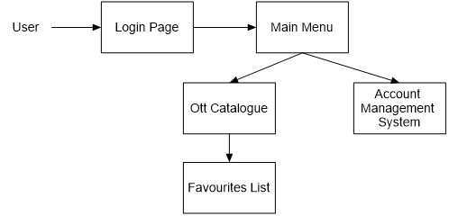

**Level 3: The Login Form**

The login form is standard for a form of this type. It provides text fields for username and password, which the user must enter before signing in. This form also gives the option for a user to register for the site if they have not yet done so.

**Level 3: The Home Page**

The home page, found at the top of the screen like in most applications. The user must choose the movie one would like to watch from here or view the genre options. Once they make these selections, the application straight aways takes the user to the watch show page for the movie to play.

**Level 3: The Account Management Form**

Currently the account management form only offers the user the option to change their password.

**Level 3: The Favourites Section**

Delving into the OTT platform's Favourites tab, a level 3 design reveals how it manages user preferences. When a user "favourites" a show, the User Interface creates a record in the Favourites table linking the user's ID with the show's Content ID. To display the Favourites list, the UI retrieves all entries from the Favourites table where the User ID matches the logged-in user. These retrieved Content IDs then act as references to pull details (titles, thumbnails etc.) from the main Content table, effectively populating the user's personalized list of favourited shows. Finally, removing a show from Favourites involves deleting the corresponding entry in the Favourites table based on User and Content IDs.

**Level 2: Database Management System Components**

The OTT platform's MySQL database acts as a central hub managed by a two-pronged Database Management System (DBMS). The Content Management System (CMS), an internal admin tool, interacts with the Content table to add, edit, and delete content details (titles, descriptions, thumbnails etc.). It might also connect with a separate video storage system. Meanwhile, the OTT Platform User Interface retrieves content information from the Content table to display options for users to browse and select shows. This level 2 design separates content management for admins from the user-facing browsing experience.

**User Interface Design**

The user interface design principles can be broken into two groups. The interface in the web application is designed to limit free form user input, using mostly drop-down menus, radio buttons and check boxes. This is done for two reasons – to simplify the ordering process as much as possible, and to limit SQL injection attempts. Free form input is necessary in the menu management component, however, as all the values must be user supplied. The interface for this component contains traditional forms comprised of text fields and corresponding labels, along with save and discard buttons for each form.

**Help System Design**

Due to the form-based nature of the applications, the design of the help systems will be minimal. In both the desktop and web applications, it will be accessed from the application's main menu and will open in a new window. Modelled after the typical help system design, it will be both searchable and include a navigation tree highlighting common topics. There will be a help page for each form type, describing the significance of each field on the page.

Testing Design

Testing Phases

The structure of the system can be divided into three main logical components, plus the database, which is invisible to the end user. Each of these components must be tested individually, and the approaches which will be used for each component are described in the following sections.



Database

Testing of the database component is very straightforward and has already been mostly completed. The database was the first component designed and before beginning work on any of the applications, we wrote all the SQL statements we expected to need and executed them directly, essentially isolating the database, using the sql client. By doing this we were able to reveal, and promptly fix a large percentage of the errors within the database itself.

ER Diagram For The Ott Platform

**Entities:**

* **User:** Represents a registered user of the OTT platform.
  + Attributes:
    - User ID (Primary Key)
    - Username
    - Hashed Password
    - Email (Optional)

**Content:** Represents a show or movie available on the OTT platform.

* + Attributes:
    - Content ID (Primary Key)
    - Title
    - Description
    - Genre
    - Release Year
    - Thumbnail URL
    - Video File Path (Foreign Key - May point to a separate storage system)

**Favorites:** (Associative Entity) Links users to their favorite content.

* + Attributes:
    - User ID (Foreign Key - References User)
    - Content ID (Foreign Key - References Content)
    - (Primary Key - Composite of User ID and Content ID)

**Relationships:**

* **One User can have Many Favorites:** A user can have many favorited shows/movies. This is represented by the relationship between the User and Favorites entities, where a User ID can be linked to multiple rows in the Favorites table.
* **One Content can be in Many Favorites Lists:** A show/movie can be favorited by multiple users. This is represented by the relationship between the Content and Favorites entities, where a Content ID can be linked to multiple rows in the Favorites table.

This ER Model provides a foundational design for the OTT platform's database, outlining the entities, their attributes, and the relationships between them. It can be further expanded to include additional features as needed.

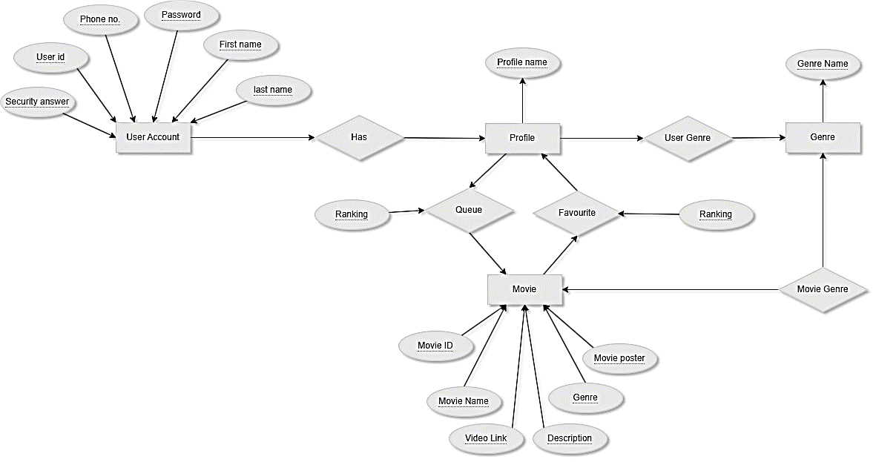

Sequence Diagram For The Ott Platform

This sequence diagram delves into the interactions between various components of the OTT platform, offering a detailed look at how elements work together to deliver a seamless user experience. The diagram will showcase the message flow between these components as a user interacts with the platform, from logging in and browsing content to selecting a show and potentially managing their favorites list.

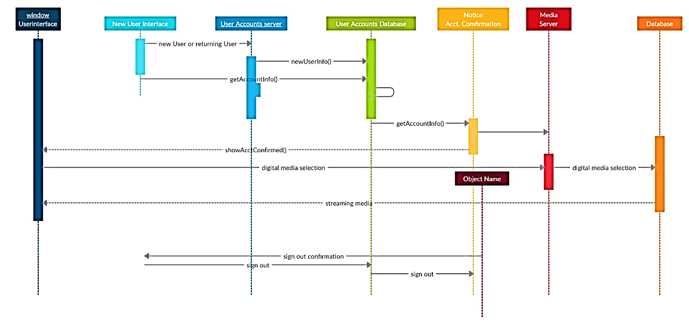

DFD For the Ott Platform

In this no-subscription OTT service, users register (if needed) and browse free content. The system manages the content library, delivers videos, and potentially recommends content based on viewing history, while generating reports on user activity for analysis.

Data Flows:

* **Users to User Management:** User registration information, login credentials (if applicable).
* **Content Providers to Content Management:** Same as before (video content, metadata, licensing agreements).
* **Content Management to Content Delivery:** Content information, user requests for specific content.
* Content Delivery to Users: Streamed video content.
* Users to Recommendation Engine (Optional): Viewing history, ratings.
* Recommendation Engine to Users (Optional): Personalized content recommendations.
* Users and Processes to Analytics: User activity data (content watched, search queries, etc.).
* Analytics to Management: Reports on user behaviour and content popularity.

Level0:  
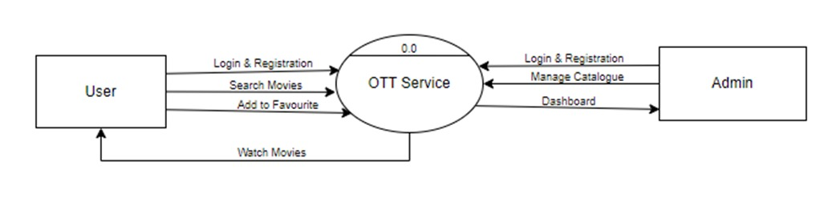

Level 1:

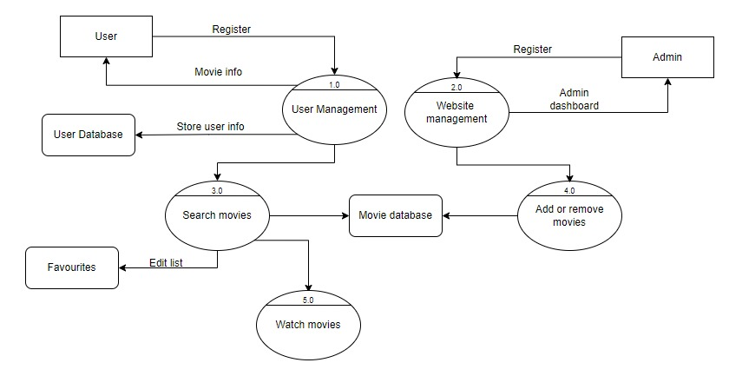

Use Case Diagram For the Ott Platform

The use case diagram depicts the OTT platform's functionalities from a user's perspective. It illustrates the various interactions a user can have with the system, including:

* **User Management:** Actors such as "Restaurant Customer" or simply "User" can interact with the system to create new accounts and manage existing ones (if that functionality is offered).
* **Content Management (Optional):** While the user cannot directly add or edit content, the diagram might show an actor representing an "Administrator" who can manage the movie catalogue (add, edit, delete).
* **Content Exploration:** Users can browse the OTT catalogue, which includes functionalities like selecting genres, searching for specific titles, and potentially retrieving details about movies.
* **Playback and Management:** Once a user selects a movie, they can interact with the playback controls (play, pause, fast-forward etc.) The use case diagram might also show users adding movies to their favourites list and potentially managing that list (removing entries). Overall, the use case diagram provides a clear visual representation of the OTT platform's core functionalities from the user's perspective.

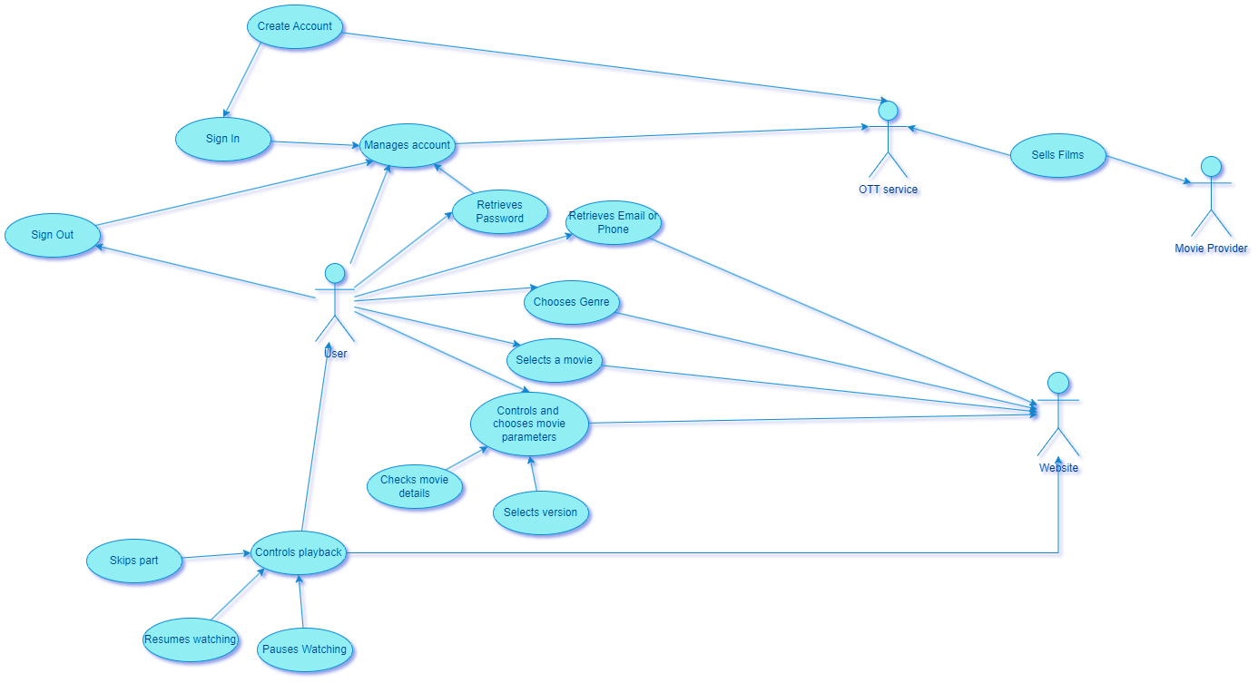

Screenshots of Project Views

Home page

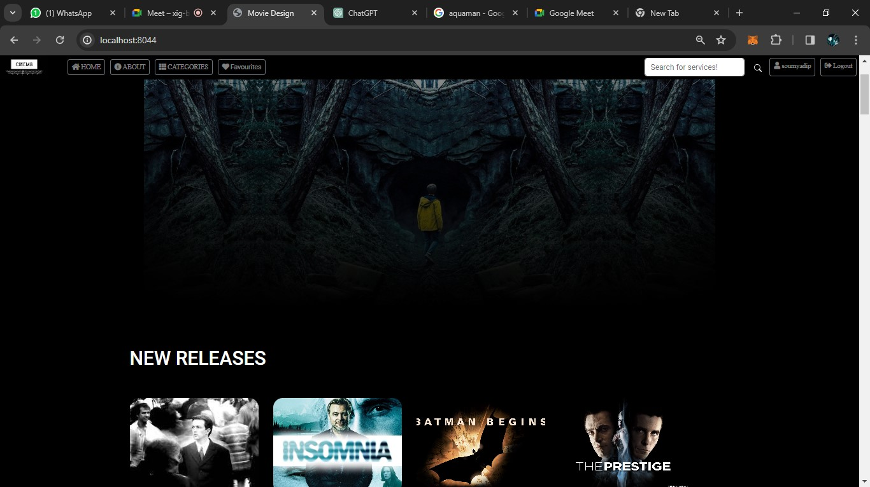

Login Page

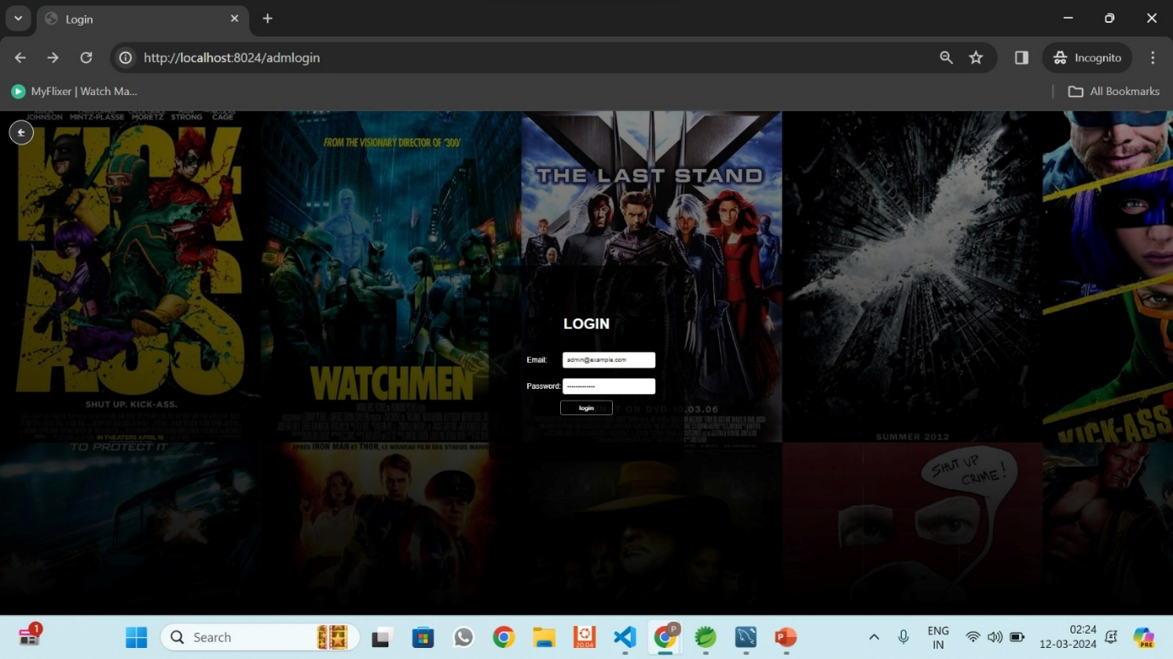

Signup Page

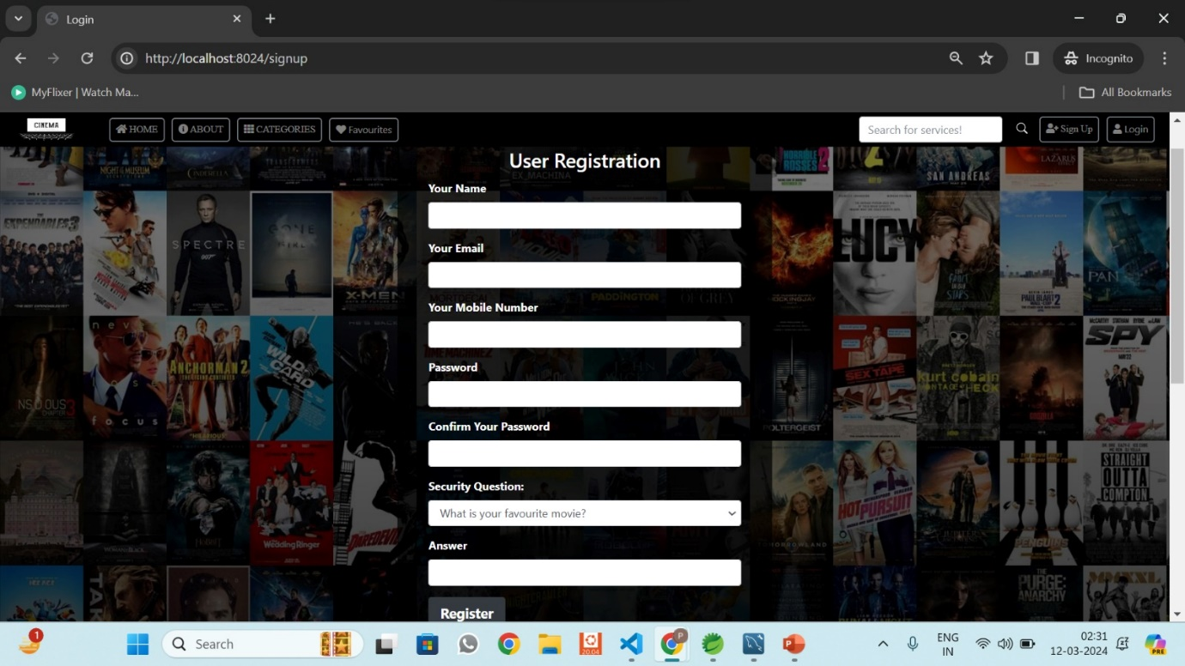

Category page

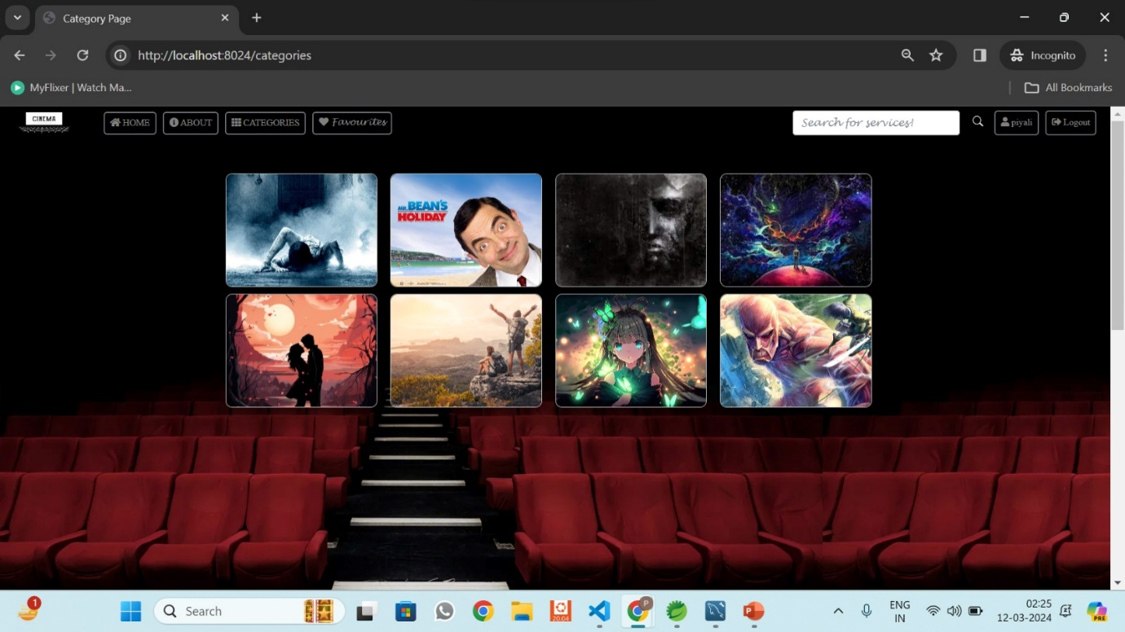

Favourites

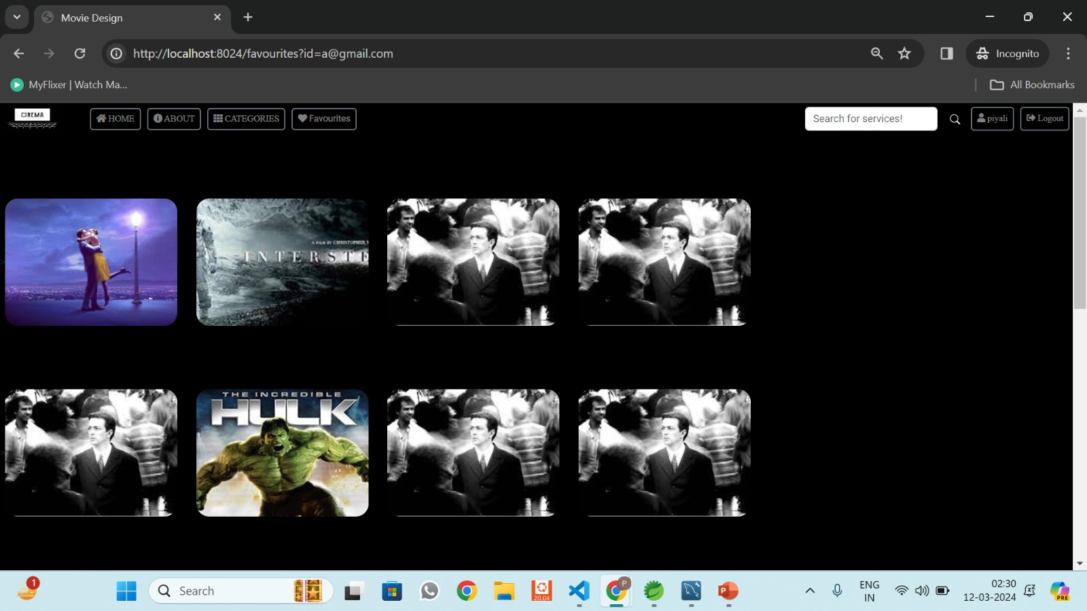

Index Footer

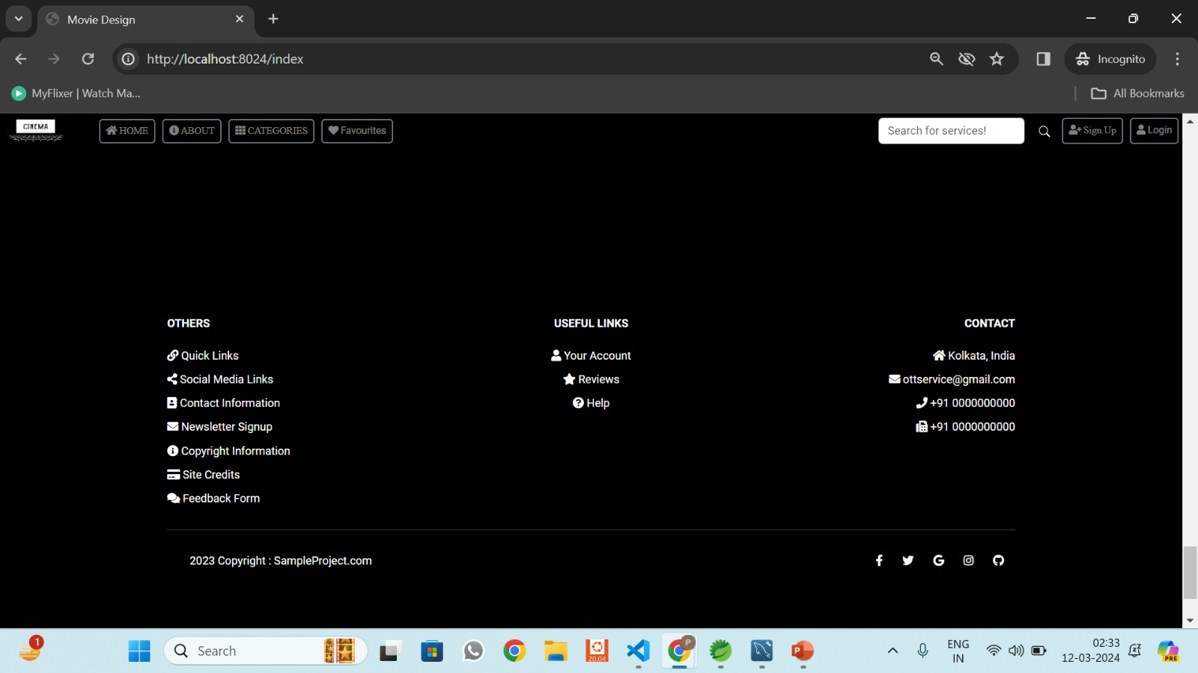

Index Header

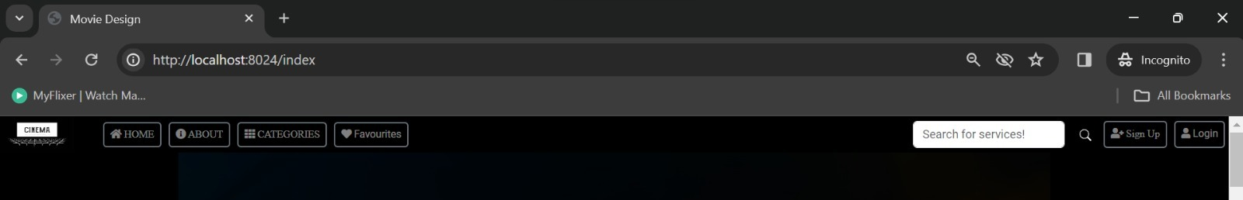

About page

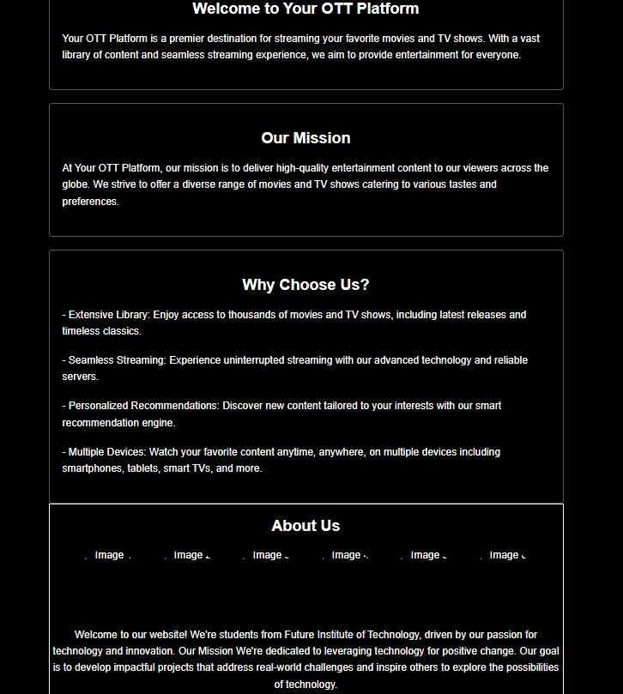

Admin Dashboard Page

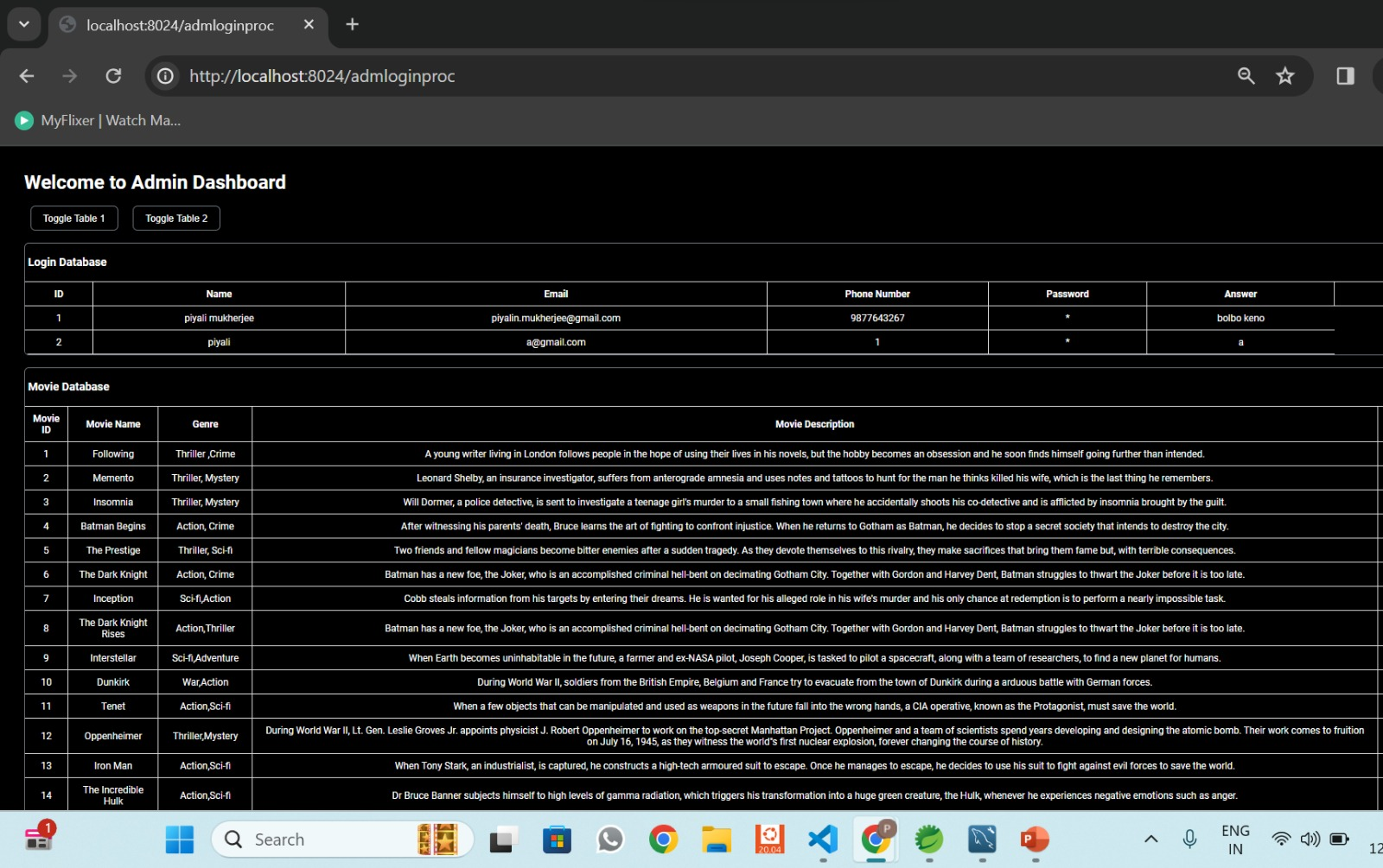

Source Code Snippet Views

catagory.jsp

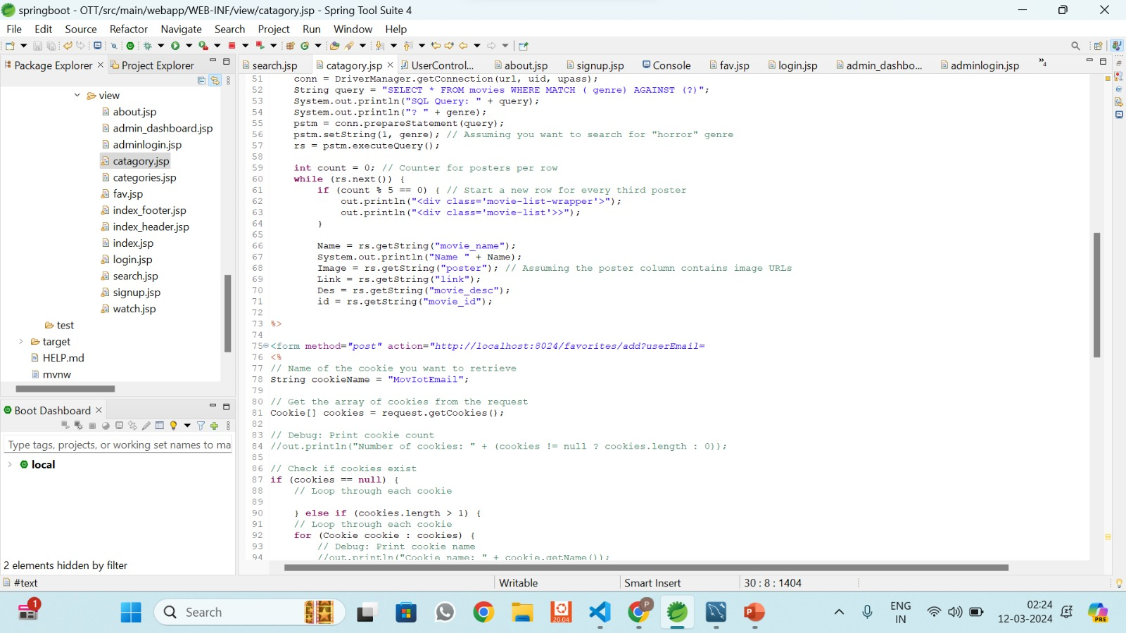

fav.jsp

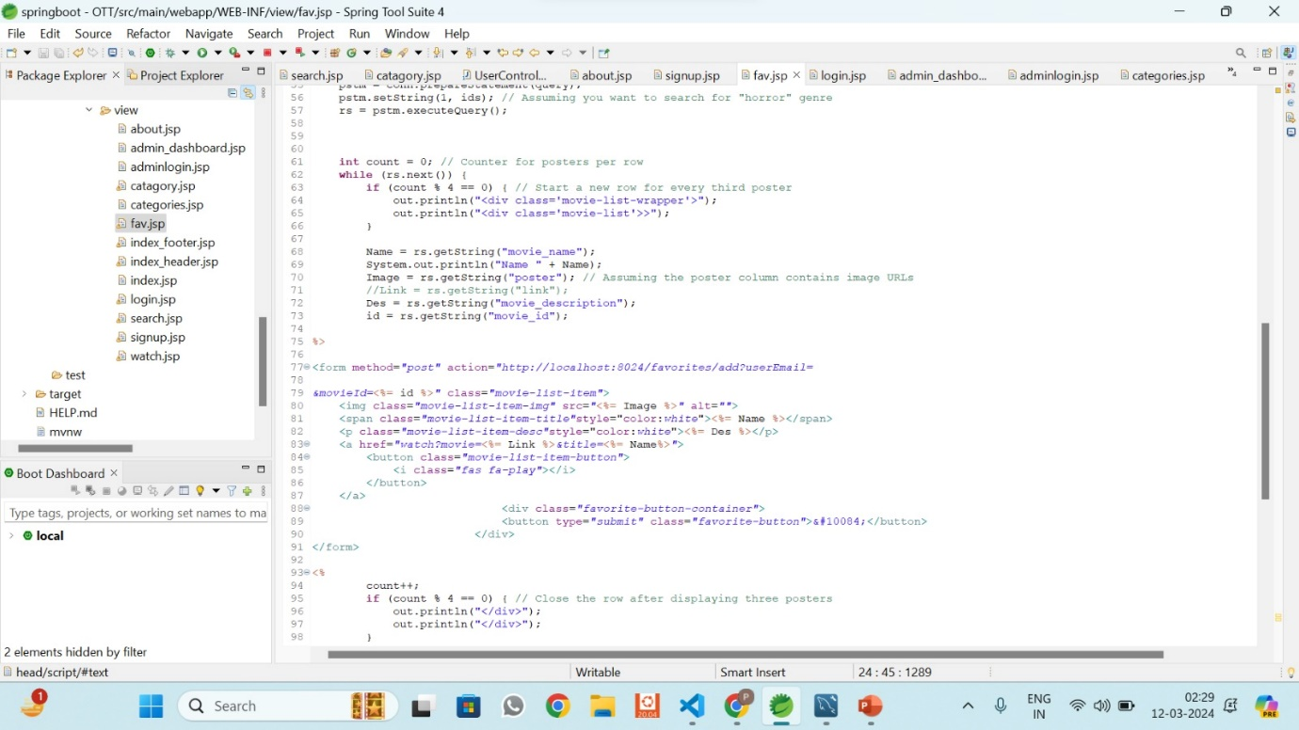

admin_dashboard.jsp

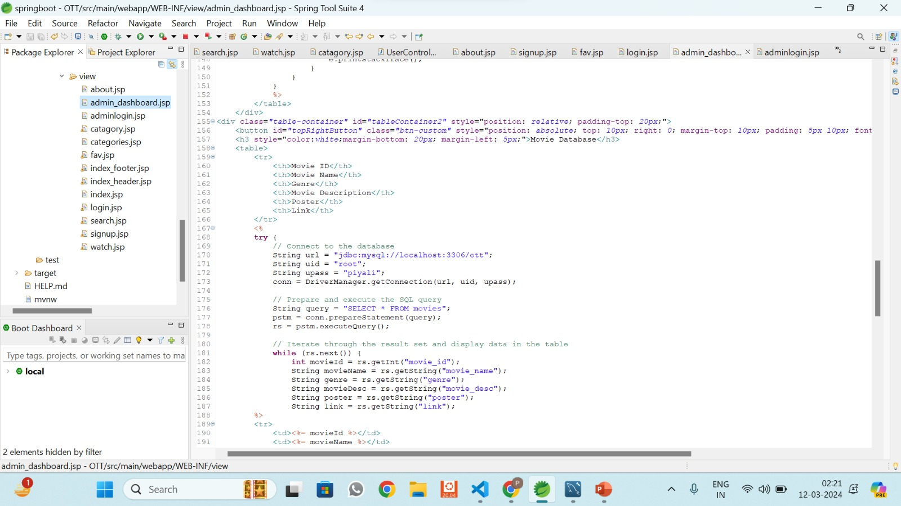

about.jsp

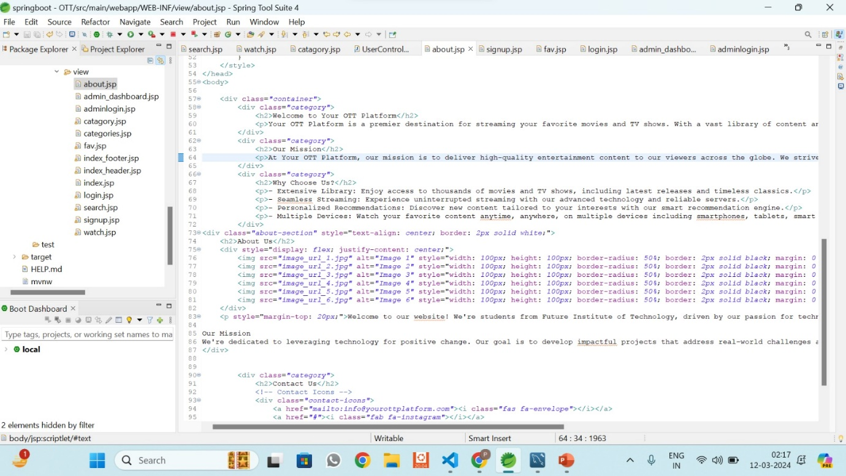

admin login.jsp

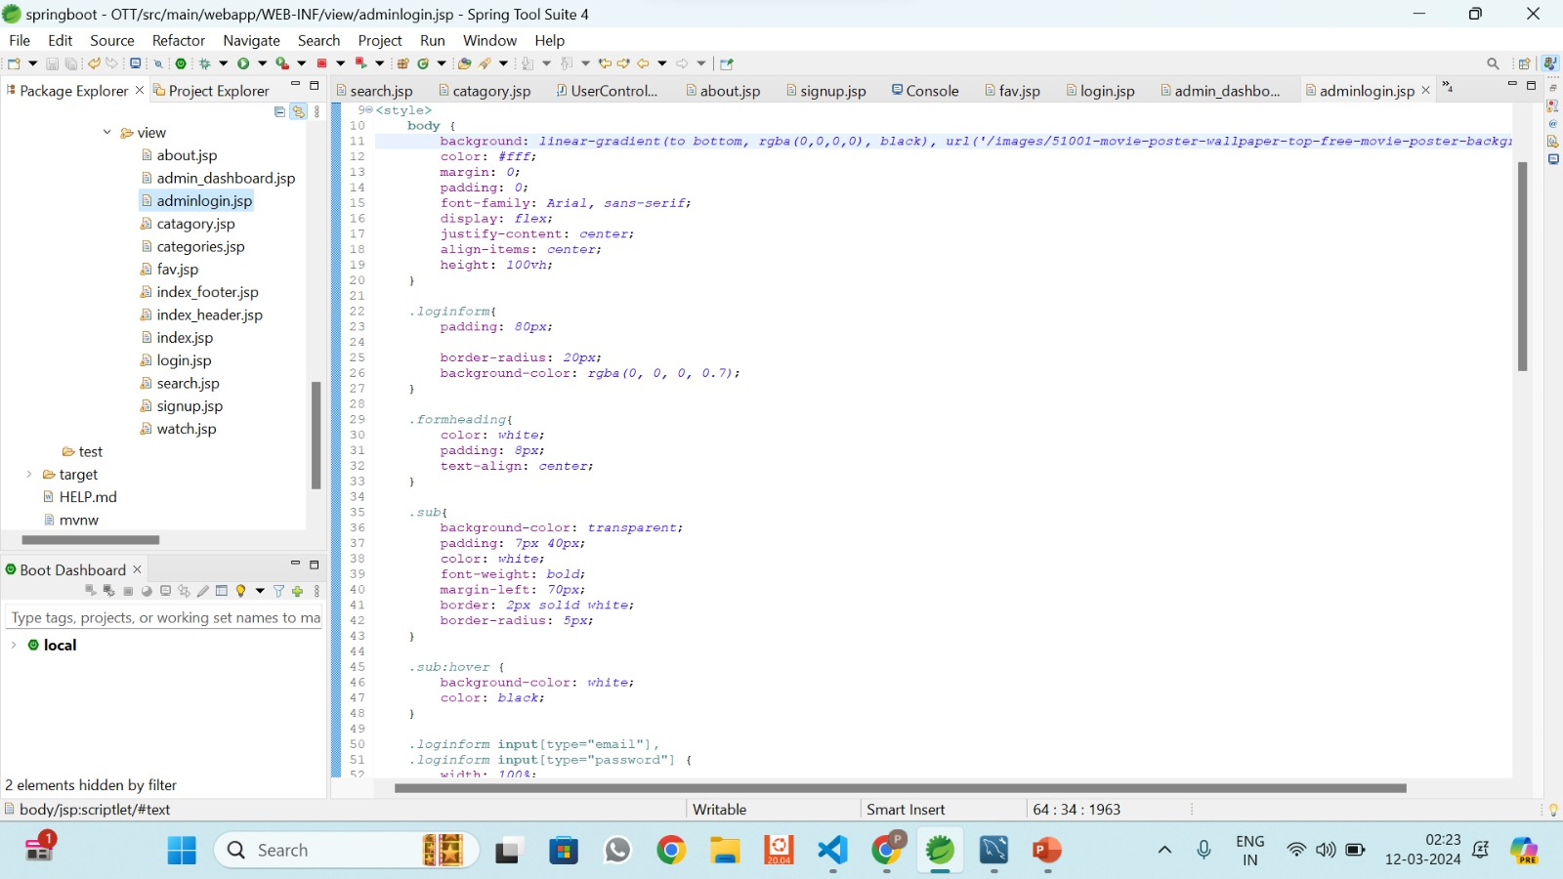

signup.jsp

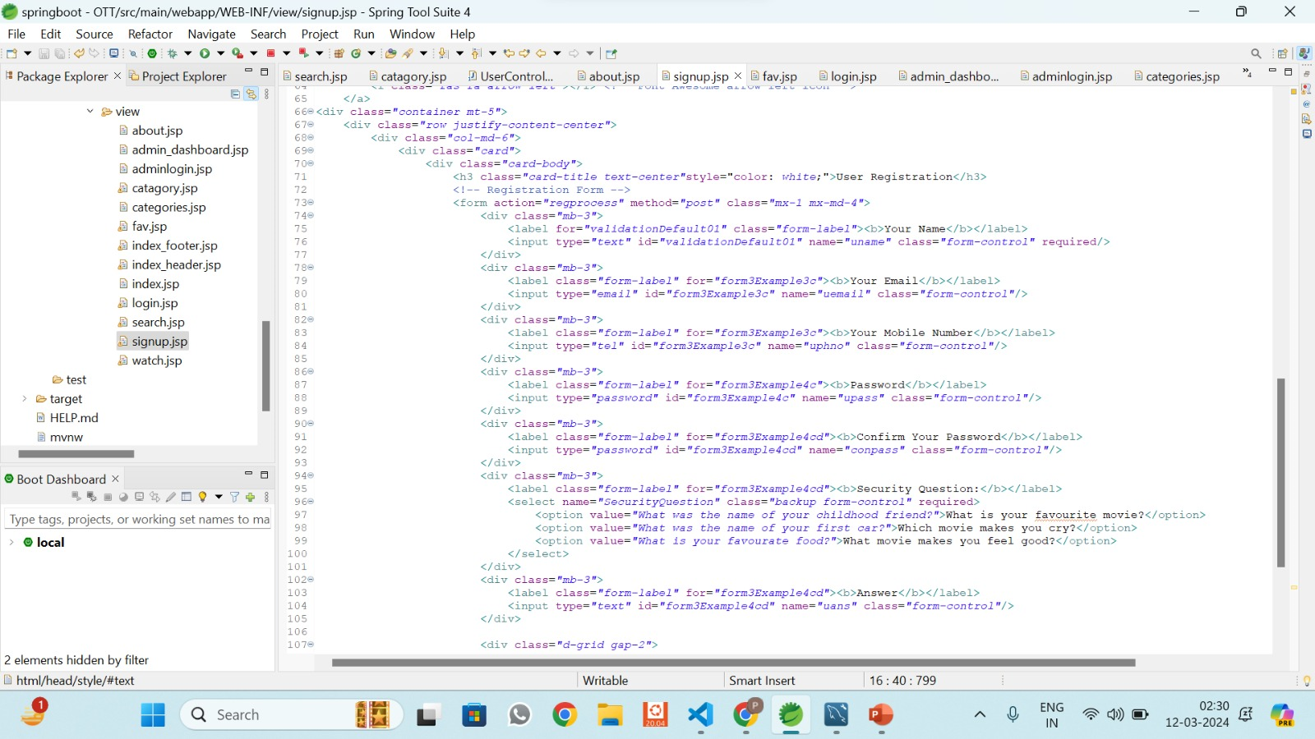

index_footer.jsp

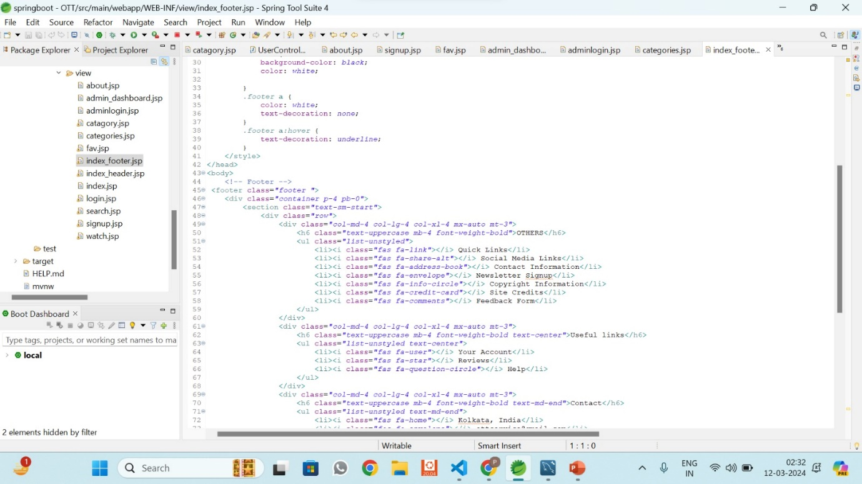

index_header.jsp

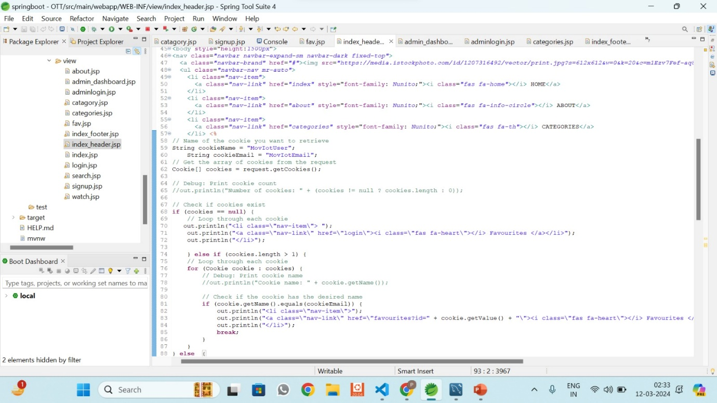

THANK YOU